**Taaha Hussain Khan**

**L1F21BSCS0917**

**DB-Lab**

**13-06-2023**

**Correlated Queries**

**Task 9:**

Write a query that displays every album title with total count of its tracks in descending order.

**[347 Rows]**

SELECT a.title, COUNT(t.TrackID) AS no_of_tracks

FROM album AS a

JOIN Track AS t

ON a.albumID = t.albumID

GROUP BY a.title

ORDER BY no_of_tracks DESC;

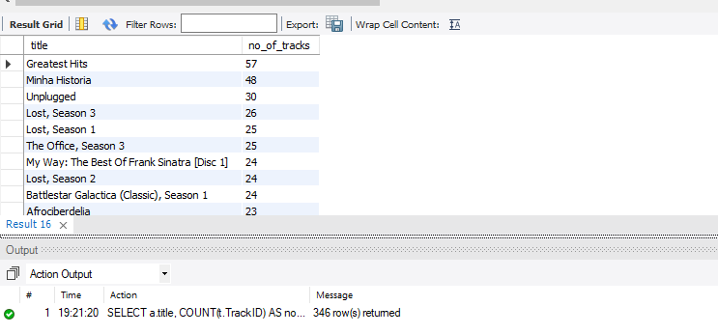

**Task 10:**

Write a query that display name of every track with min, max, average and total quantity ordered for all tracks**.**

**[1000 Rows]**

**SELECT t.Name AS TrackName,**

**MIN(il.Quantity) AS MinQuantity,**

**MAX(il.Quantity) AS MaxQuantity,**

**AVG(il.Quantity) AS AvgQuantity,**

**SUM(il.Quantity) AS TotalQuantity**

**FROM Track t**

**JOIN InvoiceLine il ON t.TrackId = il.TrackId**

**GROUP BY t.Name;**

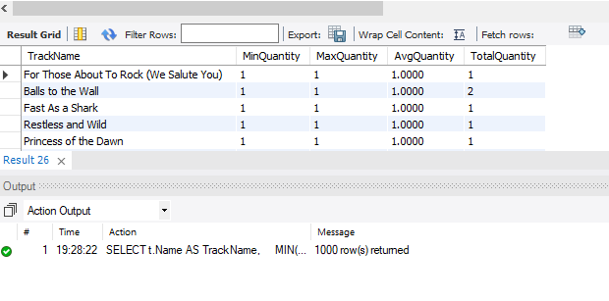

**Task 11:**

Write a query that display name of all those customers whose invoice date is in year 2013. **(Use EXISTS operator)**

**[46 rows]**

**SELECT c.FirstName, c.LastName**

**FROM Customer AS c**

**WHERE EXISTS (**

**SELECT 1**

**FROM Invoice i**

**WHERE c.CustomerId = i.CustomerId**

**AND YEAR(i.InvoiceDate) = 2013**

**);**

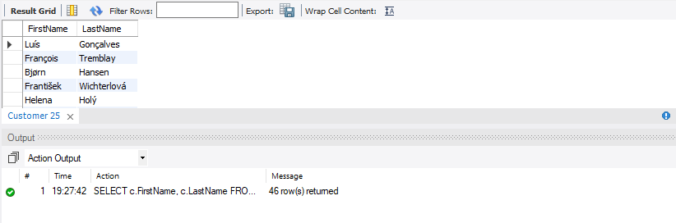

**Task 12:**

Write a query that display name of those employees whose at least one customer lives in ‘brazil’ **(Use ANY Operator)**

**[3 Rows]**

**SELECT e.FirstName, e.LastName**

**FROM Employee AS e**

**WHERE e.EmployeeId = ANY (**

**SELECT DISTINCT**

**c.SupportRepId**

**FROM**

**Customer c**

**WHERE**

**c.Country = 'Brazil'**

**);**

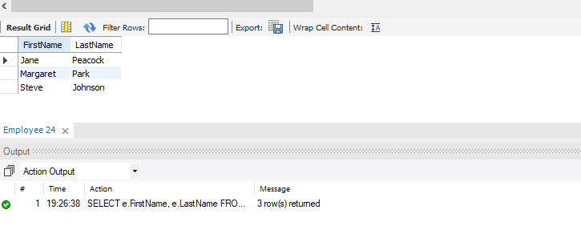

**Task 13:**

Dipslay firstname, lastname and birthdate of employee who born first**.**

**[1 Row]**

**SELECT**

**FirstName,**

**LastName,**

**BirthDate**

**FROM**

**Employee**

**WHERE**

**BirthDate = (**

**SELECT**

**MIN(BirthDate)**

**FROM**

**Employee**

**);**

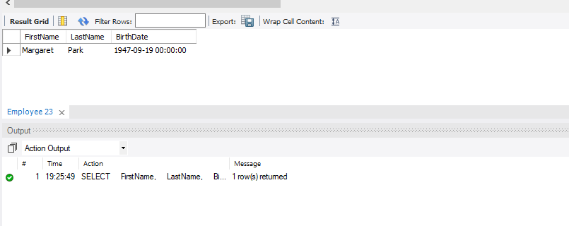

**Task 14:**

Write a correlated subquery to Display InvoiceLine Id whose Unitprices are greater than the average Unit price of all Invoices in each InvoiceLine. **[111 Rows]**

**SELECT**

**il.InvoiceLineId**

**FROM**

**InvoiceLine AS il**

**WHERE**

**il.UnitPrice > (**

**SELECT AVG(UnitPrice)**

**FROM InvoiceLine**

**);**

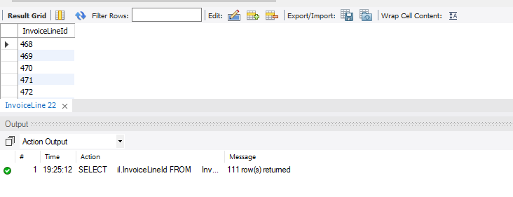

**Task 15:**

Write a correlated to display Invoice Id, Billing city billing state and total sales in descending order. **[412 Rows]**

**Hint: One Sale= unitprice* quantity**

**SELECT**

**i.InvoiceId,**

**i.BillingCity,**

**i.BillingState,**

**(**

**SELECT SUM(il.UnitPrice * il.Quantity)**

**FROM InvoiceLine il**

**WHERE il.InvoiceId = i.InvoiceId**

**) AS TotalSales**

**FROM**

**Invoice AS i**

**ORDER BY**

**TotalSales DESC;**

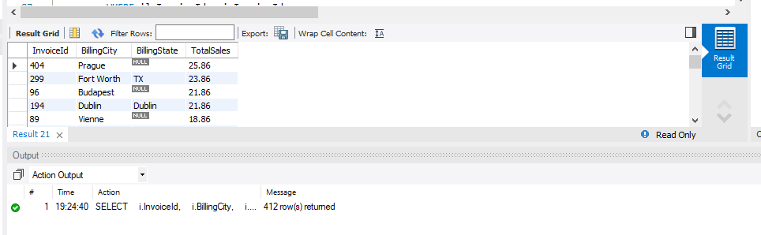

**Task 16:**

Write a query to display the employee_id, manager_id, first_name and last_name of those employees who manage other employees. **[3 Rows]**

**SELECT**

**e1.EmployeeId,**

**e1.ReportsTo AS ManagerId,**

**e1.FirstName,**

**e1.LastName**

**FROM Employee AS e1**

**WHERE EXISTS (**

**SELECT 1 FROM Employee AS e2**

**WHERE e2.ReportsTo = e1.EmployeeId**

**)**

**ORDER BY**

**e1.EmployeeId;**

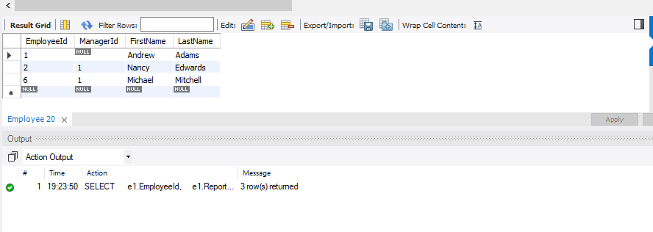

**Task 17:**

Write a correlated subquery display invoice information having latest date. **[1 Row]**

SELECT

InvoiceId,

CustomerId,

InvoiceDate,

BillingAddress,

BillingCity,

BillingState,

BillingCountry,

BillingPostalCode,

Total

FROM Invoice

WHERE InvoiceDate = (

SELECT

MAX(InvoiceDate)

FROM

Invoice

);

